Lab 11: Application Load Balancer (Path Based Routing)

Path-based routing (also called URL routing) allows your Application Load Balancer (ALB) to route incoming requests to different target groups based on the request path (the part of the URL after the domain). Path-based routing is essential in microservices architecture, multi-app hosting, or anything needing scalability and clean architecture under a single domain. It simplifies complexity, enhances scalability, improves cost-efficiency, and allows separation of concerns.
Suppose you have:
- /api → should go to a backend service (EC2s or containers in Target Group A)
- /app → should go to a frontend app (EC2s or containers in Target Group B)
When a user accesses:
- https://example.com/api/users → request is routed to Target Group A
- https://example.com/app/home → request is routed to Target Group B
Additionally ,Imagine you have a company website:
- https://company.com/app → Frontend React app
- https://company.com/api → Node.js backend
- https://company.com/admin → Internal admin panel
Without path-based routing:
- You’d need 3 load balancers or 3 subdomains.
- You’d need to manage SSL certificates for each.
- It would cost more and add operational overhead.
With path-based routing:
- You just use one ALB.
- Set routing rules:
  - /app/* → Target Group A (frontend)
  - /api/* → Target Group B (backend)
  - /admin/* → Target Group C (admin)
To Set up Path based Routing edit listener rules on your application load balancer.

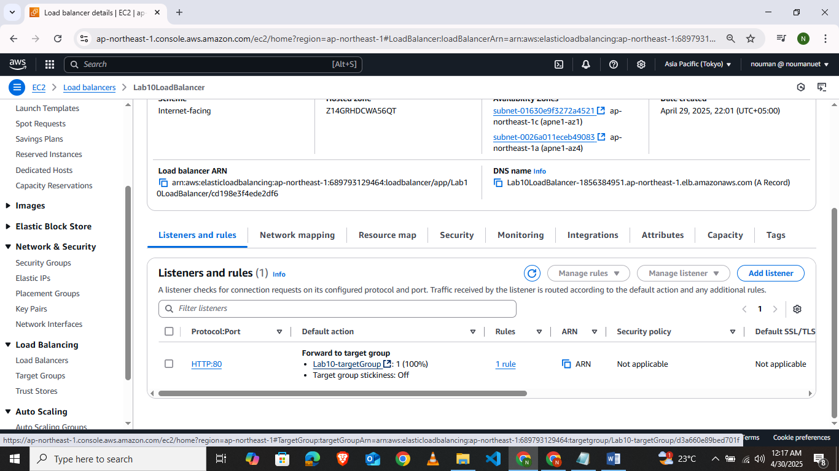
Click on edit or add rules

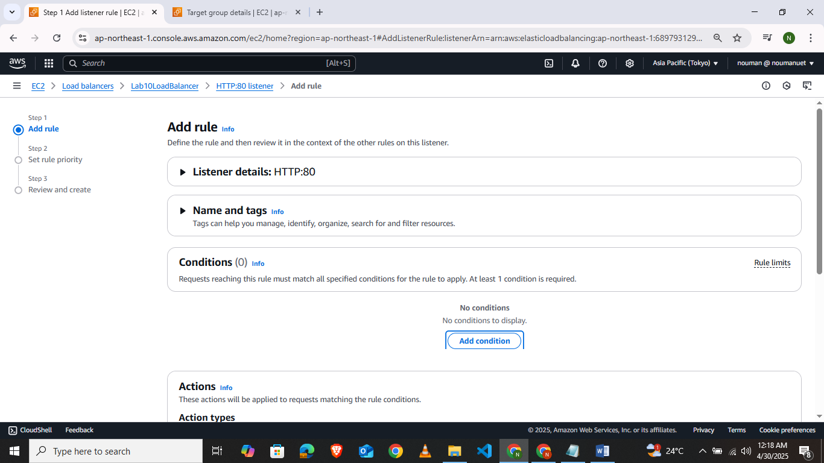
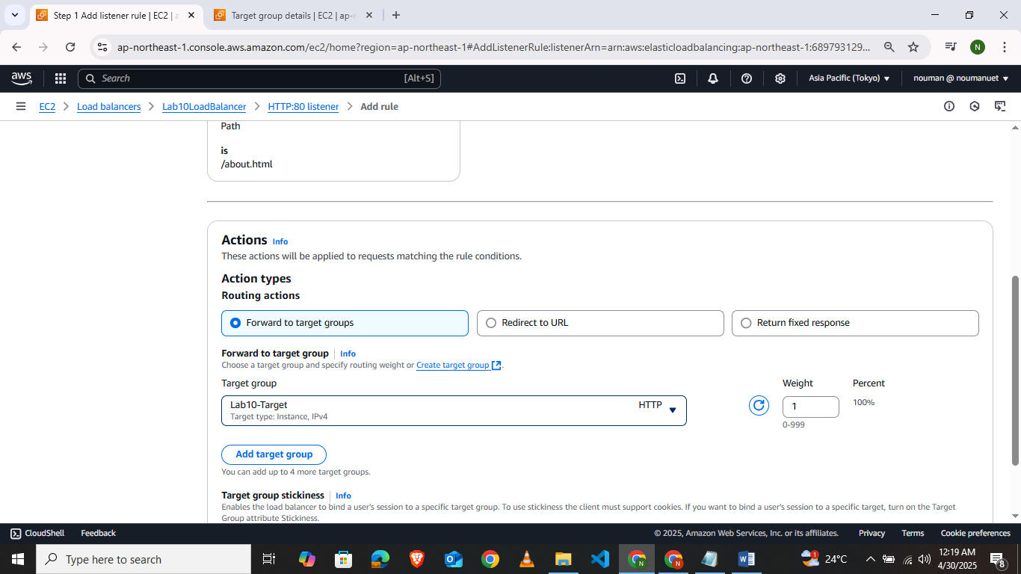
This way you can route traffic to the intended target group.

Lab Task:
1. Implement the following
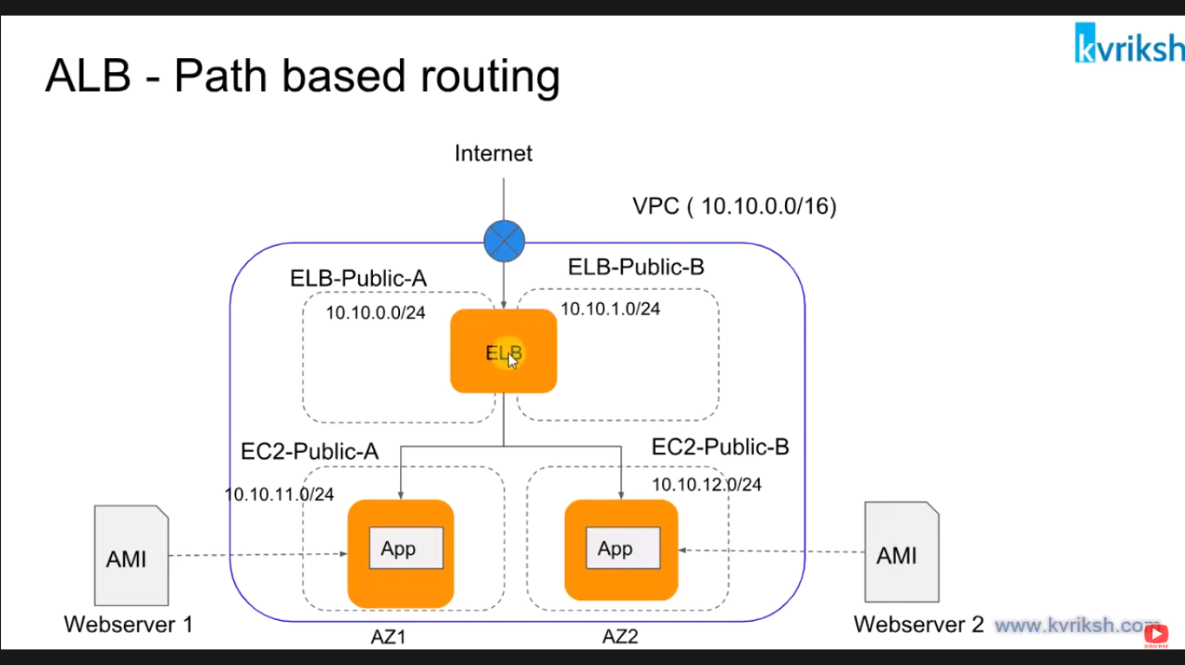
2. Implement Path based routing using ALB with AutoScaling groups. Serve any static html page from you auto scaling groups to differentiate between both. Remember to terminate your instances once done.

